Doc Writer: Pavan y Doc Date: Dec 15, 2015.

Application or System Name
Enrollment update from DRMS
General Overview
- This requirement is to get enrollment updates from DRMS into SAP. This update will let SAP know that against the DPP enrolled SAP customers how many of them actually got enrolled in DRMS and the nature of error which prevented the enrollment in DRMS.
- This inbound interface is used to get DRMS Enrollment update confirmation in SAP. In case of any failure the DPP Enrollment table is updated with DRMS Enrollment failed status and corresponding failure reason.
- Alternative to this object is manual exchange of information between the DRMS and SAP. This in turn will create delays to sync up DRMS enrollment information with SAP Enrollment information.
The monthly reconciliation report can also be used for syncing DRMS enrollment information with SAP.
- SAP will be aware of the customers which are successfully enrolled in SAP but are not successfully enrolled in DRMS. This can be helpful in monthly enrollment reconciliation as well.
- Once the Enrollment is completed in SAP using the DPP batch report which runs in SAP every day after billing, a DRMS enrollment trigger is raised from SAP using outbound interface in End device service request canonical format. SAP BMD delta updates also reports the enrollment information in batch every day to ESB, which in turn makes to DRMS using BMD delta from ESB to DRMS. Both these are smartly used by ESB to trigger Enrollment in DRMS.

This End_Device_Service_requestes is used to initiate enrollment in DRMS.

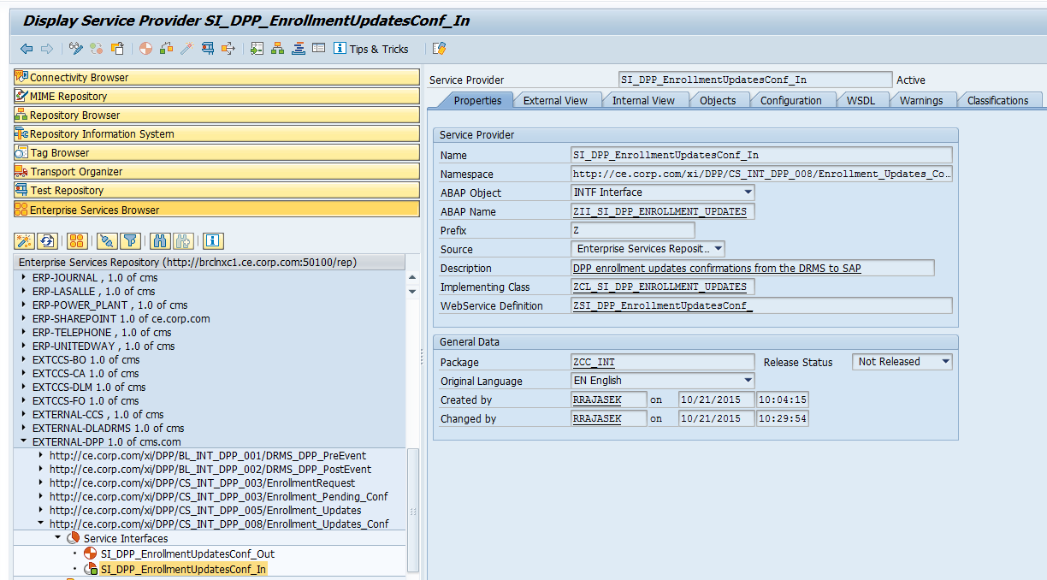

So once the DRMS enrollment is completed/failed, they’ll send the enrollment confirmation information with a log of success and failure against each account and customer to ESB.
This new interface which will be created and the Enrollment confirmation received from DRMS into ESB to SAP.
ESB scope includes: The creation of a new interface from ESB to SAP to send DRMS enrollment confirmation.
SAP scope includes: Consuming the new interface and implementing the method inside the proxy class to read from the proxy structure and update the DPP enrollment table field DRMS Enrollment status as success or failure based on the interface inputs. This can later be used by program management to check the DRMS enrollment status of DPP enrollment customers in SAP.
Technical Design:
Function Modules:

SAP Reconciliation Interface processing logic:
In this functionalist inbound interface is used to get DRMS Enrollment update confirmation in SAP.
It has two interface PO is the middleware and we can send the data to sap and In case of any failure the DPP Enrollment table is updated with DRMS Enrollment failed status and corresponding failure reason.
- Go to transaction code ‘sproxy’ is an object navigator
Here go to Enterprise Services Browse (Source, SWCs, Packages, Namespaces, Object types and Objects) in Source go to ESR->SWCs->External-DPP 1.0->Namespace->Enrollment_updates_conf->objects.
Here we will find some service interfaces like SI_DPP_ Enrollmentupdatesconf_in
Go to the implementation class ZCL_SI_DPP_ENROLLMENT_UPDATES and using that Instance method ZII_ SI_DPP_ENROLLMENT_UPDATES~ SI_ENROLLMENT_UPDATES_CONF is called and this method will handle the enrollment updates from the DRMS.
For this we will create a class <ZCL_ISU_DPP_DISPATCH> this method will handle the enrollment update from the DRMS (Demand Response Management System).
In the above class we will create a method <CREATE_MAP_IMPL_DRMS_INSTANCE>
In this we can find the header level values
IF ls_header-verb = 'create'(001) AND
ls_header-noun = 'EndDeviceServiceRequests'(002) AND
ls_header-source = 'EV'(003).
* return an instance of the service implementing class
CREATE OBJECT lr_ev_map_instance TYPE zcl_isu_se_map_dpp.
CREATE OBJECT lr_ev_impl_instance TYPE zcl_isu_se_impl_dpp.
y_instance_map ?= lr_ev_map_instance.
y_instance_impl ?= lr_ev_impl_instance.
lv_type = 'ZSDPP_INT_DATA'.
CREATE DATA o_dataref TYPE (lv_type).
ENDIF.
In the method <CREATE_MAP_IMPL_DRMS_INSTANCE> we will create two classes implementation class and mapping class.
Implementation Class<ZCL_ISU_SE_IMPL_DPP_DRMS> create a method<PROCESS>
Here it will checks data exist in the table <ZTPGM_INT_DATA> based on the correlation ID , and <ZTPGM_ENROLL> get the Enrollment Data from Enrollment business partner number, and Enrollment contract Account number, Enrollment program type and enrollment requested date.
Mapping Class<ZCL_ISU_SE_MAP_DPP_DRMS> create a method<MAP_DRMSUPDATE_IN>
This method maps data from the enrollment request from the enrollment vendor.
Here we will get the enrollment data from the tables <ZTPGM_INT_DATA> and <ZTPGM_ENROLL> based on the correlation Id, Enrollment business partner number, and Enrollment contract Account number, Enrollment program type and enrollment requested date.
SELECT SINGLE * ##WARN_OK
INTO ls_int_data
FROM ztpgm_int_data
WHERE zcorrelid_ref = xy_appldata-pgm_int_data-zcorrelid_ref.
IF sy-subrc = 0.
SELECT SINGLE *
INTO ls_enroll
FROM ztpgm_enroll
WHERE zenrlbp = ls_int_data-zenrlbp
AND zenrlca = ls_int_data-zenrlca
AND zpgm_type = ls_int_data-zpgm_type
AND zenrl_reqdat = ls_int_data-zenrl_date.
ENDIF.
Consuming the new interface and implementing the method inside the proxy class to read from the proxy structure and update the DPP enrollment table field DRMS Enrollment status as success or failure based on the interface inputs. This can later be used by program management to check the DRMS enrollment status of DPP enrollment customers in SAP.

IF x_input-changed_end_device_service_req-reply-result = 'OK'.
* xy_appldata-pgm_enroll-zenrldrms_stat = '1'.
IF ls_enroll-zenrlstatus = '002'.
xy_appldata-pgm_enroll-zenrldrms_stat = '1'.
ELSEIF ls_enroll-zenrlstatus = '004'.
xy_appldata-pgm_enroll-zenrldrms_stat = '2'.
ENDIF.
xy_appldata-pgm_enroll-zdrms_dat = sy-datum.
ELSE.
* xy_appldata-pgm_enroll-zenrldrms_stat = '6'.
IF ls_enroll-zenrlstatus = '002'.
xy_appldata-pgm_enroll-zenrldrms_stat = '6'.
ELSEIF ls_enroll-zenrlstatus = '004'.
xy_appldata-pgm_enroll-zenrldrms_stat = '7'.
ENDIF.
xy_appldata-pgm_enroll-zdrms_dat = sy-datum.
ENDIF.
When zenrlstatus is ‘002’and zenrldrms_stat is ‘1’ then Enrollment complete in DRMS and enrollment complete in sap.
When zenrlstatus is ‘004’and zenrldrms_stat is ‘2’ then De-Enrollment complete in DRMS and De-Enrollment complete in sap.
When zenrlstatus is ‘002’and zenrldrms_stat is ‘6’ then Enrollment complete in DRMS and enrollment failed in sap.
When zenrlstatus is ‘004’and zenrldrms_stat is ‘7’ then De-Enrollment complete in DRMS and De-Enrollment Failed in sap.

System Diagram

Technical Parts Inventory
-------Name------- | ----Description---- | -----Location----- | ----Environment---
sproxy | Transaction Code |  | E2D
ZCL_SI_DPP_ENROLLMENT_UPDATES | Impl Class |  | E2D
ZCL_ISU_DPP_DISPATCH | Class |  | E2D
ZCL_ISU_SE_IMPL_DPP_DRMS | Class |  | E2D
ZCL_ISU_SE_MAP_DPP_DRMS | Class |  | E2D
ZTPGM_ENROLL | Table |  | E2D
ZTPGM_INT_DATA | Table |  | E2D

Dependent Parts Inventory
-------Name------- | ----Description--- | -----Location----- | ----Environment---
N/A | N/A | N/A | N/A

PO Interface Technical Design Documentation:
Overview
This interface shall facilitate the confirmation from DRMS for enrollment updates for customers in DPP programs. The DRMS updates the enrollment status of the customer to modify whether the customer is participating in DPP programs and sends a message in response to the request from SAP to the DRMS.
Interface | DPP Enrollment Updates Confirmation
Folder | DPP
ICO | | ESBCORPD2 | SI_DPP_EnrollmentUpdatesConf_Out | |
Pattern | SOAP to PROXY (ESB to ECC)
Below are the interface details.
Sender Details:
Business System | ESBCORPD2
Service Interface | SI_DPP_EnrollmentUpdatesConf_Out
Namespace | http://ce.corp.com/xi/DPP/CS_INT_DPP_008/Enrollment_Updates_Conf

Receiver Details:
Business System | E2D
Service Interface | SI_DPP_EnrollmentUpdatesConf_In
Namespace | http://ce.corp.com/xi/DPP/CS_INT_DPP_008/Enrollment_Updates_Conf

Operation Mapping:
Name | none

Communication Channel Details

Sender Communication Channel
Name | sender_ESB_DPP_EnrollmentUpdatesConf
Adapter | SOAP

Screen Shot Sender Communication Channel

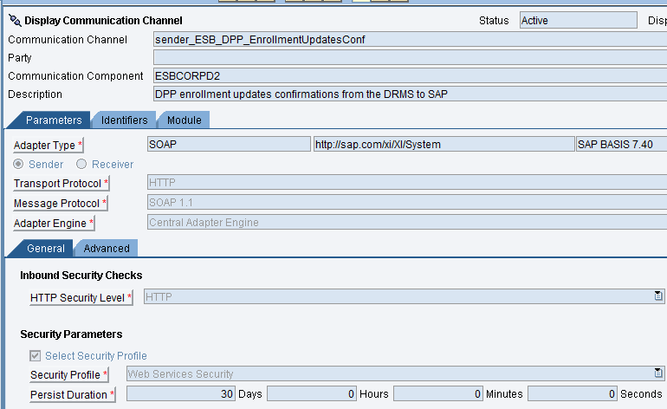

Receiver Communication Channel
Name | CC_DPP_XI_Receiver
Adapter | SOAP (ABAP Proxy)
Destination | E2DCLNT150DPP

Screenshot of Receiver Communication Channel
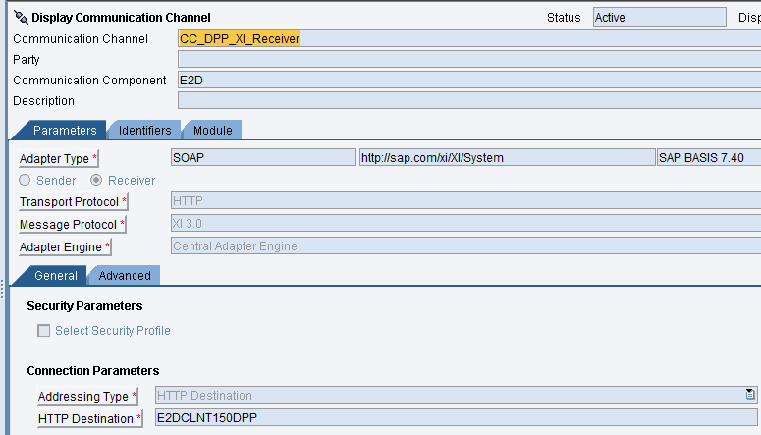
Message Mapping
No Mapping Objects exist as the Outbound and Inbound Service Interfaces use structures from same WSDL definition.

Revision History
Version | Author(s) | Date | Significant Changes
1.0 | Ed Abranovich | 01/06/15 | Approved Baseline Work Product
0.1 | Pavan y | 12/15/15 | Initial Document Release

